Experiment no 7

**Aim:** Implementation of Circular Linked List ADT

**Objective:** Circular Linked List can be used to manage the Computing Resources of the computer. Data Structure such as stacks and queue are implemented with the help of circular linked list

**Theory :**

The circular linked list is a linked list where all nodes are connected to form a circle. In a circular linked list, the first node and the last node are connected to each other which forms a circle. There is no NULL at the end.

**Algorithm:**

Insertion at beginning of the list:

* Step 1: NOW IF POINTER = NULL (GO TO STEP 11)
* Step 2: ASSIGN NEW NODE = POINTER
* Step 3: ASSIGN POINTER = POINTER → NEXT
* Step 4: ASSIGN NEW NODE → DATA = VALUE
* Step 5: ASSIGN TEMP NODE = HEAD
* Step 6: REPEAT STEP 8 WHILE TEMP → NEXT != HEAD (END OF WHILE LOOP)
* Step 7: ASSIGN TEMP NODE = TEMP → NEXT
* Step 8: ASSIGN NEW NODE → NEXT = HEAD
* Step 9: ASSIGN TEMP NODE → NEXT = NEW NODE
* Step 10: ASSIGN HEAD = NEW NODE
* Step 11: EXIT

Insertion at end of the list:

* Step 1: IF HEAD = NULL (END OF IF AND GO TO STEP 8)
* Step 2: ASSIGN POINTER = HEAD
* Step 3: WHILE POINTER -> NEXT != HEAD (REPEAT STEP 4 AND 5)
* Step 4: ASSIGN PREVIOUS_POINTER = POINTER
* Step 5: ASSIGN POINTER = POINTER -> NEXT (END OF WHILE LOOP)
* Step 6: ASSIGN PREVIOUS_POINTER -> NEXT = HEAD
* Step 7: REMOVE POINTER
* Step 8: EXIT

Deletion at beginning of the list:

* Step 1: IF HEAD = NULL ( GO TO STEP 8 )
* Step 2: NOW SET POINTER = HEAD
* Step 3: REPEAT STEP 4 UNTIL POINTER → NEXT != HEAD
* Step 4: ASSIGN POINTER = POINTER → NEXT (END OF LOOP)
* Step 5: ASSIGN POINTER → NEXT = HEAD → NEXT
* Step 6: FREE HEAD NODE
* Step 7: ASSIGN HEAD = POINTER → NEXT
* Step 8: EXIT

**Code :**

#include <stdio.h>

#include <stdlib.h>

// Structure for a node

struct Node {

int data;

struct Node* next;

};

// Function to insert a node at the

// beginning of a Circular linked list

void push(struct Node** head_ref, int data)

{

// Create a new node and make head

// as next of it.

struct Node* ptr1 = (struct Node*)malloc(sizeof(struct Node));

ptr1->data = data;

ptr1->next = *head_ref;

// If linked list is not NULL then

// set the next of last node

if (*head_ref != NULL) {

// Find the node before head and

// update next of it.

struct Node* temp = *head_ref;

while (temp->next != *head_ref)

temp = temp->next;

temp->next = ptr1;

}

else

// For the first node

ptr1->next = ptr1;

*head_ref = ptr1;

}

// Function to print nodes in a given

// circular linked list

void printList(struct Node* head)

{

struct Node* temp = head;

if (head != NULL) {

do {

printf("%d ", temp->data);

temp = temp->next;

} while (temp != head);

}

printf("\n");

}

// Function to delete a given node

// from the list

void deleteNode(struct Node** head, int key)

{

struct Node *last = *head, *d;

// If linked list is empty

if (*head == NULL)

return;

// If the list contains only a

// single node

if ((*head)->data == key && (*head)->next == *head) {

free(*head);

*head = NULL;

return;

}

// If head is to be deleted

if ((*head)->data == key) {

// Find the last node of the list

while (last->next != *head)

last = last->next;

// Point last node to the next of

// head i.e. the second node

// of the list

last->next = (*head)->next;

free(*head);

*head = last->next;

return;

}

// Either the node to be deleted is

// not found or the end of list

// is not reached

while (last->next != *head && last->next->data != key) {

last = last->next;

}

// If node to be deleted was found

if (last->next->data == key) {

d = last->next;

last->next = d->next;

free(d);

}

else

printf("Given node is not found in the list!!!\n");

}

// Driver code

int main()

{

// Initialize lists as empty

struct Node* head = NULL;

// Created linked list will be

// 2->5->7->8->10

push(&head, 2);

push(&head, 5);

push(&head, 7);

push(&head, 8);

push(&head, 10);

printf("List Before Deletion: ");

printList(head);

deleteNode(&head, 7);

printf("List After Deletion: ");

printList(head);

return 0;

}

**Output:**

: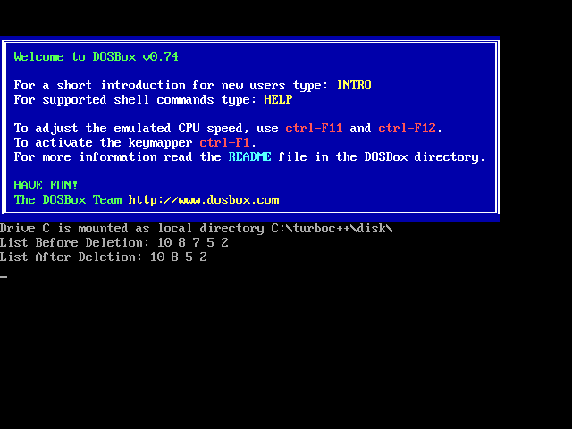

**Conclusion** : The Circular Link list is implemented